EXPERIMEMENT:3 Create a simple cloud software application for Car Booking Reservation System using any Cloud Service Provider to demonstrate SaaS include the necessary fields such as search for cabs, from, to, rental , out station, Package type, hours/Days etc.

Step:1 create a application form for car passenger details

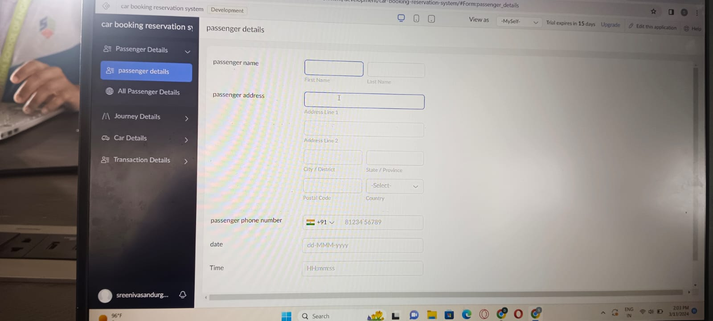

Step:2: CREATE A PPLICATION FORM FOR A CAR DETAILS

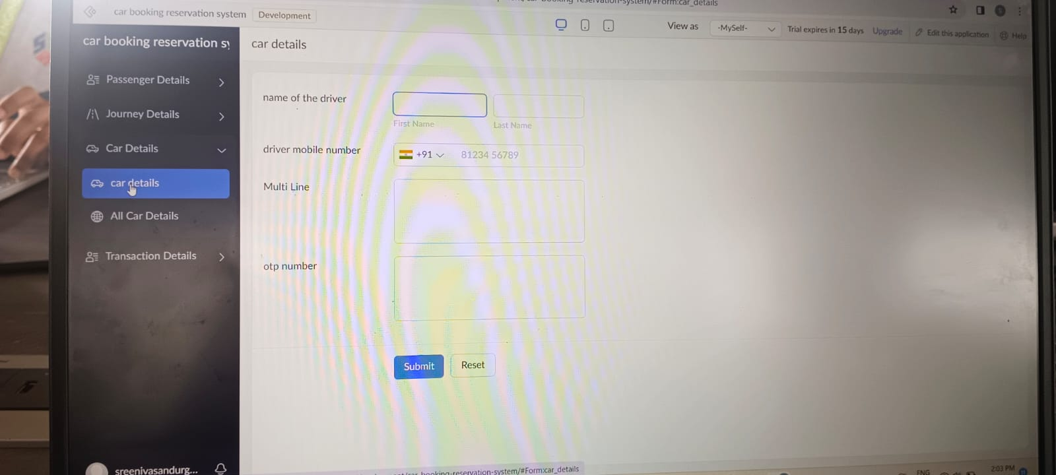

STEP:3 CREATE A APPLICATION FORM A TRANSACTION DETAILS.

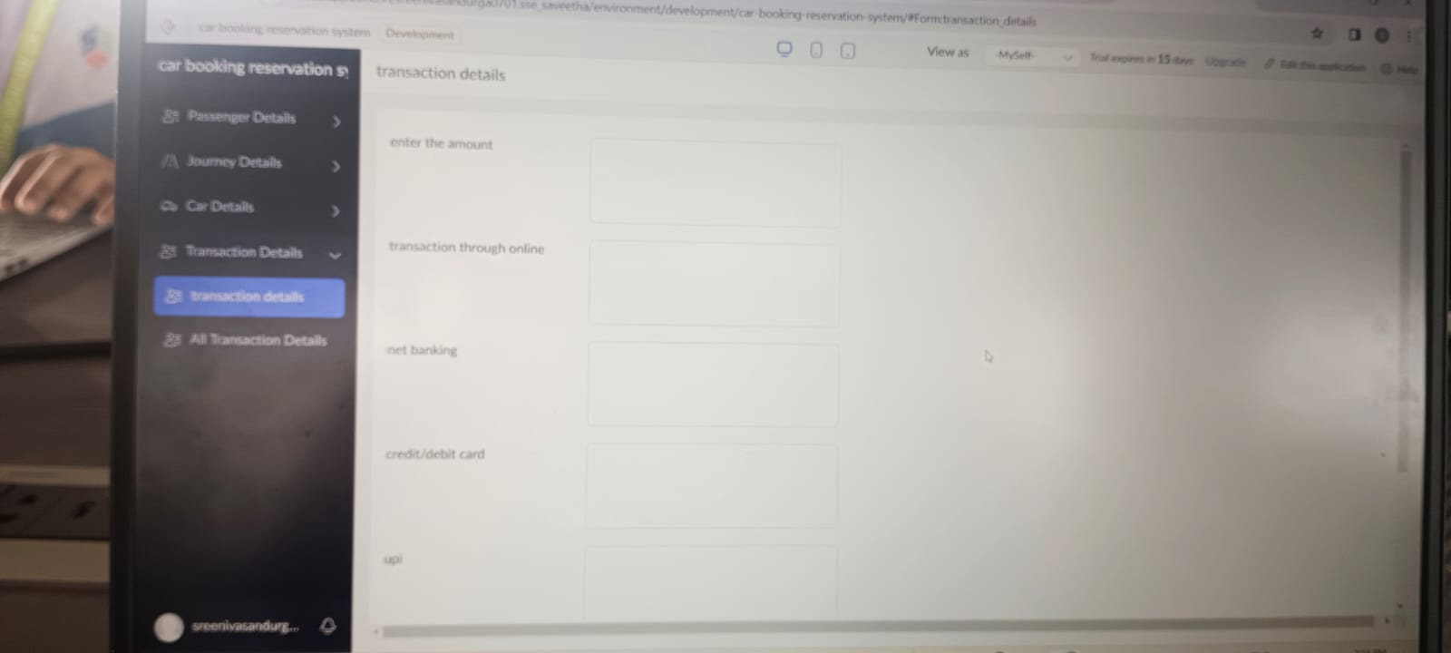

STEP:4: CREATE A APPLICATION FORM FOR CAR PASSENGER RESULT.

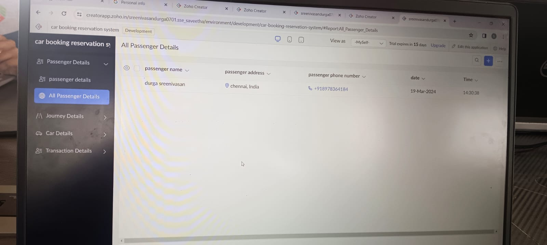

RESULT: THUS,THE PROGRAM HAS BEEN EXCEUTED SUCCESSFULLY.